**Name: Sanika Mehetre**

**Roll No: 34**

**Div:D15B**

**Advance DevOps-12**

**Aim**:To create a Lambda function which will log “[An Image has been added](https://docs.google.com/document/d/1kgHgwHhX-FwH4Cbeof3u1ipqHYxyXeGL/edit?usp=sharing&ouid=116507495392702976626&rtpof=true&sd=true)” once you add an object to a specific bucket in S3

**Theory:**

**AWS Lambda and S3 Integration:** AWS Lambda allows you to execute code in response to various events, including those triggered by Amazon S3. When an object is added to an S3 bucket, it can trigger a Lambda function to execute, allowing for event-driven processing without managing servers.

**Workflow:**

1. **Create an S3 Bucket:**

○ First, create an S3 bucket that will store the objects. This bucket will act as the trigger source for the Lambda function.

1. **Create the Lambda Function:**

○ Set up a new Lambda function using AWS Lambda’s console. You can choose a runtime environment like Python, Node.js, or Java.

○ Write code that logs a message like “An Image has been added” when triggered.

1. **Set Up Permissions:**

○ Ensure that the Lambda function has the necessary permissions to access S3. You can do this by attaching an IAM role with policies that allow reading from the bucket and writing logs to CloudWatch.

1. **Configure S3 Trigger:**

○ Link the S3 bucket to the Lambda function by setting up a trigger. Specify that the function should be triggered when an object is created in the bucket (e.g., when an image is uploaded).

1. **Test the Setup:**

○ Upload an object (e.g., an image) to the S3 bucket to test the trigger. The Lambda function should execute and log the message “An Image has been added” in AWS CloudWatch Logs.

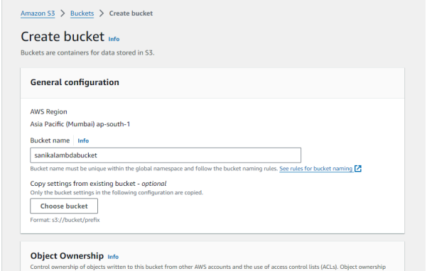

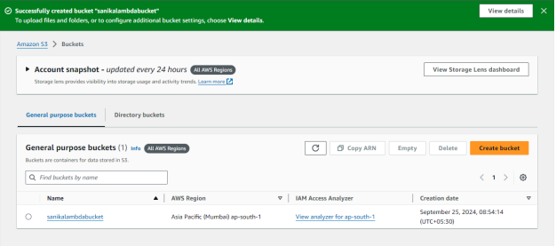

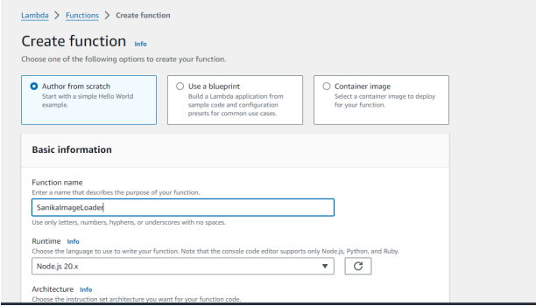

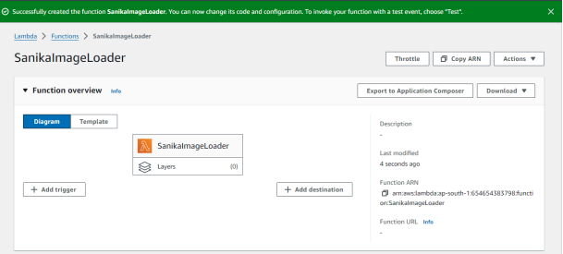

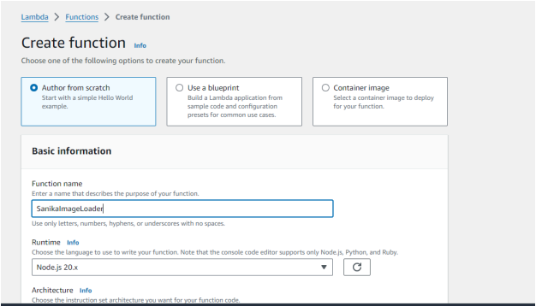

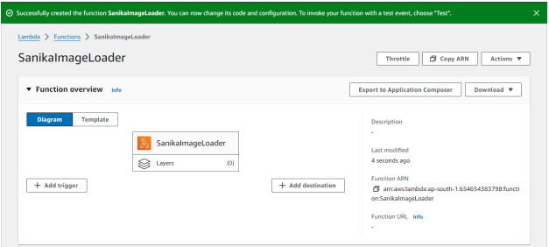

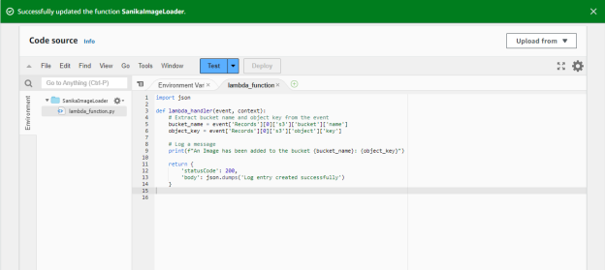

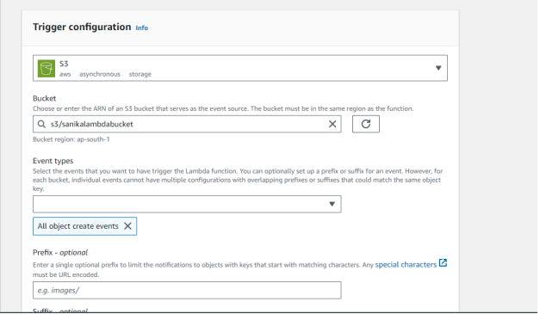

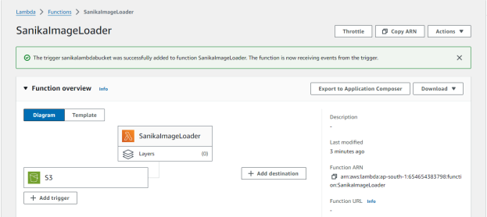

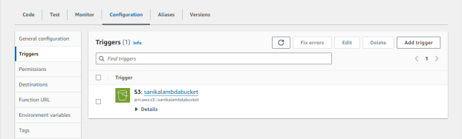

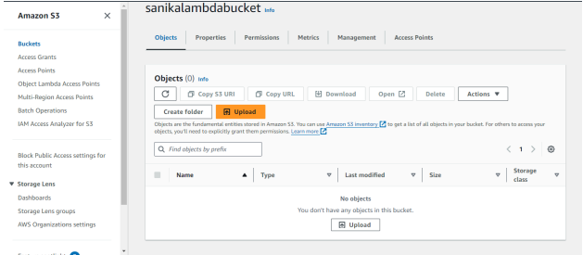

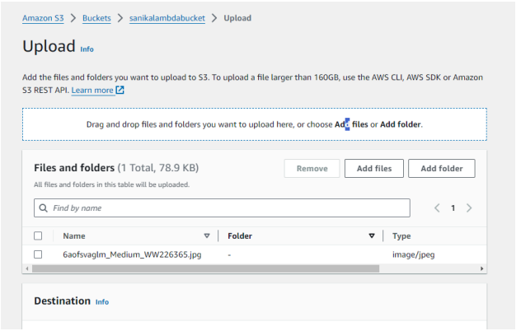

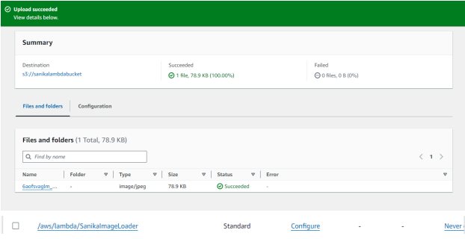



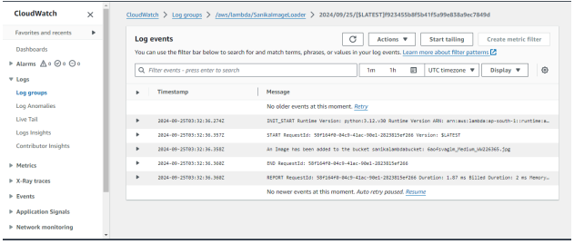

**Conclusion:**

Integrating AWS Lambda with S3 allows for real-time, automated processing of events such as file uploads. In this example, a Lambda function is configured to log a message whenever an image is added to a specific S3 bucket. This setup demonstrates the power and flexibility of serverless computing by automating tasks without requiring manual intervention or server management. By leveraging AWS Lambda, developers can efficiently handle event-driven workflows, reduce operational overhead, and quickly deploy scalable solutions that respond to specific actions within cloud environments.